Oculus Quest 1 and 2 Airlink setup
Oculus Quest 1 and 2 supports streaming VR games from a desktop computer using either a USB link cable or over WiFi using Airlink. This makes the stand-alone VR headset act like a regular wired PC headset such as HTC Vive or the original Oculus.
Airlink requires a powerful WiFi-6 enabled router to work smoothly. It is necessary that the router always uses the 5 Ghz band (not the 2.4 Ghz band like on old routers). It is only better to use a router with multiple CPUs (preferably quadcore) as streaming VR can be very heavy.
It seems to be possible to use a modern phone in-place of a router. By enabling mobile hotspot and connecting both the PC and the headset to the phone, Airlink can connect through the phone with a connection good enough be allow for a smooth experience.

Step-by-step guide for setting up Airlink without a router:
- Install the Oculus software on a powerful laptop.
- Ensure the laptop is plugged into an outlet (powersaving mode reduces performance).
- Enable mobile hotspot on your phone.
- Connect the Oculus Quest and the laptop to the hotspot.
- Click the oculus air link button on the Quest.
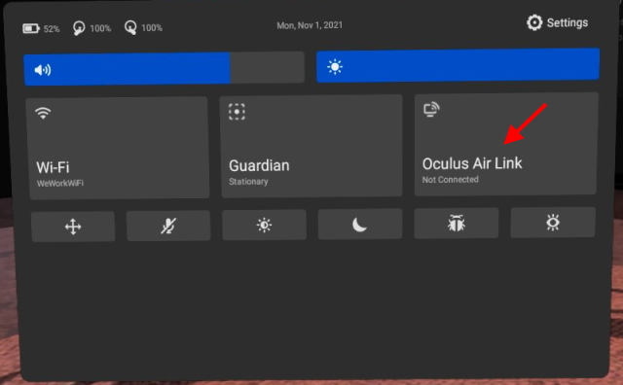
- Start SteamVR on the laptop.
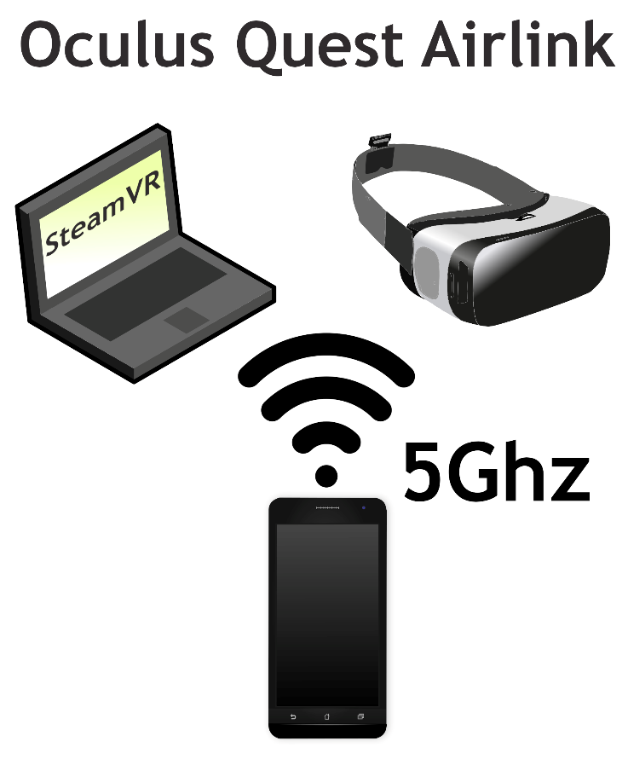
- Open your VR game/application.

